**CREATING A USER ACCOUNT IN** **SHU ORACLE**

To create an Oracle account, students must register as an Oracle User. For this you will need your *Network* *Username,* *Student* *Number,* *Family* *name,* and *Date* *of* *Birth*.

To invoke the form shown below choose **Start** **/** **Programs** **/** **Applications** **/** **Oracle** **/** **Create** **Oracle** **User** from the Start Menu.

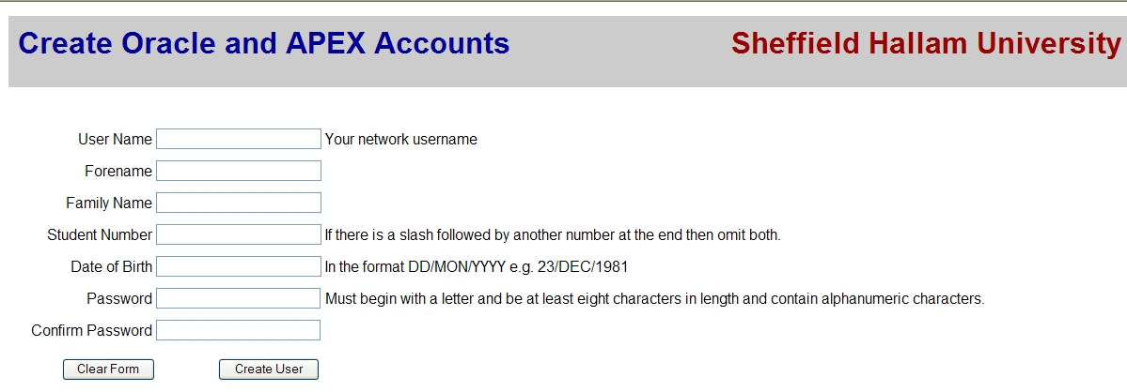

Enter your Log-in Id, Name and Student Number

The format for Date of Birth is dd/mmm/yyyy, e.g. 01/JAN/1982

Choose a password (one that you will remember!). The password rules:

• **eight** characters in length

• start with a letter

• the remainder may be letters or numbers

• Oracle passwords are NOT case sensitive

Click the 'Create User' button, **and** **wait**. Interrupting the process can corrupt your Oracle details and you may not be able to re-run the process. If successful you now have a personal and private Oracle environment and two accounts: one for Oracle, the DBMS, and one for APEX development tool. Both use the same username and password. (We will not be using APEX in this module).

Once the account is created, if it becomes locked and/or you need to change the password, you can do it here: <https://dbutils.shu.ac.uk/oracleutility>

In the case you cannot find Oracle, through the ‘Start’ menu, please visit the address: <https://dbutils.shu.ac.uk/oracleutility>

If we visit this address, we get the following page:

In the above page, you need to login with your University credentials (SHU username, SHU password). When you login with your University credentials, press the button ‘Login’ and the page you will see is the following:

In the above page, you will need to define a Password for your Oracle SHU account. The rules for the creation of this password should be the following:

• **eight** characters in length

• start with a letter

• the remainder may be letters or numbers

• Oracle passwords are NOT case sensitive

When you create your password following the above rules, press the button ‘Update Password’ and then the button ‘Logout’.

You should receive an email to your University email account as a confirmation that you have created your Oracle SHU account.

The next step is to login to Oracle SQL Developer using your newly created Oracle SHU account and following the instructions entitled: ‘Connecting to an ORACLE database using Oracle SQL Developer at SHU’. These instructions can be found in the next pages of this document.

Even though in the module we will not use Oracle APEX (this is the web interface of Oracle SQL Developer), the Oracle SHU account that you created allows you to login to APEX.

In this case, you will need to go to the following address:

<http://homepages.shu.ac.uk:7777/pls/apex/f?p=4550:1:3133227558998>:::::

Or you can just go to the Google search engine and type: Oracle SHU APEX 7777

When you run this query in Google and you get the results, you will need to click to the first result entitled ‘Oracle Application Express – Homepages Home Page’. When you login to Oracle APEX, your username and your workspace should be the same.

If you decide Oracle SQL Developer on your personal computers, then you will need to visit the following address for the latest version:

<https://www.oracle.com/tools/downloads/sqldev-downloads.html>

The interface among different versions is exactly the same.

In this case, you will need to create an Oracle account (through <https://login.oracle.com/mysso/signon.jsp>) which is different from your Oracle SHU account.

You can also explore Oracle Cloud Infrastructure and especially the Free Tier but this is your personal choice. For example, in the Oracle Cloud Infrastructure, you can create Autonomous Databases and then you use SQL Developer Web to handle your databases.

**Connecting to an ORACLE database using Oracle SQL Developer at SHU**

Launch Oracle SQL Developer from AppsAnywhere.

Once loaded, right-click on Connections and choose New Connection. Use the dialogue box which then appears to connect, as below.

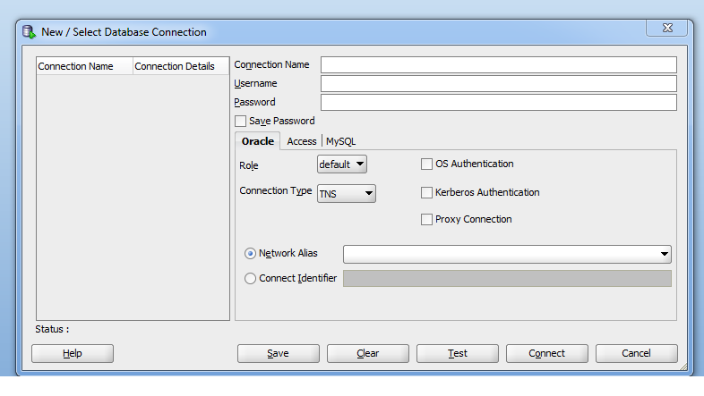

Specify any connection name, but use your Oracle user name and password

Click Test, and if the status reads ‘Success’, then click Connect.

Choose connection type TNS

Choose network alias SHU11g

**Connecting from Home**

You can download and install SQL Developer (free from the Oracle website) to your own PC and use it to access your Oracle database from outside SHU.

To do that needs a slightly different connection process. Instead of connection type TNS, you must choose connection type BASIC, and then in the new fields which appear enter:

SID: SHU11G

Service name: shu11g.shu.ac.uk

Hostname: homepages.shu.ac.uk

Port: 1521

Test it, and then press ‘Connect’ if it succeeds.